Rotary Public Image Resources
- Goal: Increase awareness and understanding of Rotary across all of our districts and around the world.
  - You can’t get the “word out” if everything we say looks and sounds different.
  - Consistency and repetition, starting at the local level, is how we get the word out.
  - There are MANY resources to help you be consistent in your communications!

- Rotary Brand Center: www.rotary.org/brandcenter or brandcenter.rotary.org
  - Also accessible from My Rotary under the Manage tab.
  - No longer need to log in using rotary.org (My Rotary) credentials.
  - Includes guides, logos, images, ads, customizable templates, videos, and so much more.

- Brand Guidelines:
  - Includes the basics for branding: messaging, logos, fonts, colors, imagery, and more.
  - Now only available from Brand Center as web pages.
  - Logos are the most important at this time. All districts and clubs need to use the same template.

- People of Action campaign
  - Access customizable templates from Brand Center.
  - Highlight Rotarians doing service projects and the benefits.
  - See online guidelines on Brand Center.

- Tips and Tricks
  - ALWAYS use the “new” logo: the word Rotary plus a wheel after it with your club or district name.
  - NEVER use the wheel by itself – it must be used with the official Rotary “word” logo.
  - Never use posed pictures, “grip and grin,” or “big check” photos – these do not separate Rotary from other organizations. We want to show people in action in our communities.
  - Make sure photos feature people in action and represent the diversity of your club and community.
  - Make sure your club and district materials ALL LOOK THE SAME, following the Brand Guidelines: It’s only through a consistent message and look and feel that we can communicate the brand value of Rotary.
  - ALWAYS include a Call to Action: website URL, email address, phone number, social media page, etc.

- Where to go for help
  - Brand Center
  - Your district Public Image Chair
  - Zone Rotary Public Image Coordinator (RPIC) and Assistant Public Image Coordinators (ARPICs)
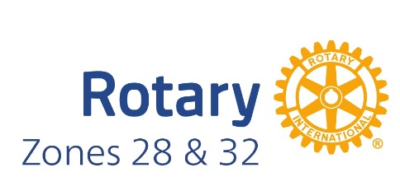
  - Rotary International: see email addresses on guides or Brand Center

